HALF ADDER

1. S = AB’ + A’B

C = A.B

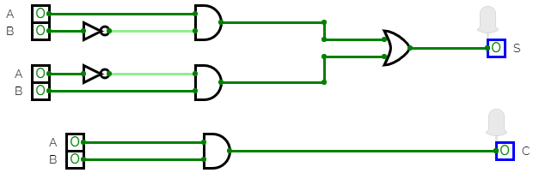

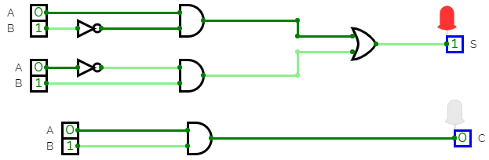

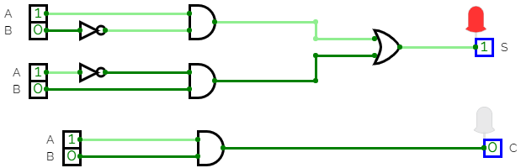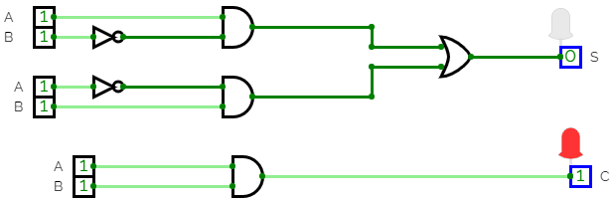

B)S = AB’ $⊕$ A’B

C = A.B

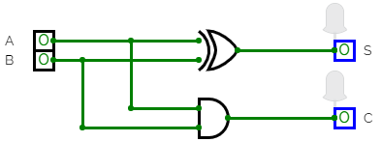

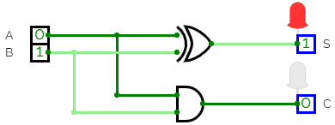

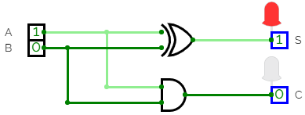

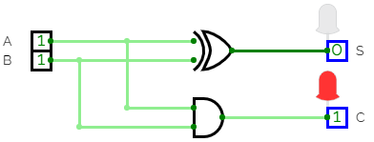

HENCE HALF ADDER IS IMPLEMENTED.